

Umpires Training Manual

A guide for prospective Umpires
and Players

About this document

Unfortunately due to the constant evolution of the sport of pétanque, its rules and various other interpretations, it is almost impossible to compile a manual that will not require ongoing amendments. This document is therefore a ‘guide’ rather than a comprehensive course. The written word, however, is no substitute for the benefits gained from ‘on the job’ experience during a tournament

Therefore, this document is intended to be used merely as a “stepping stone” and introduction to further instruction as deemed necessary for the individual’s needs. In it you will find advice for prospective umpires and some of the rules that are often misinterpreted.

So you want to be an Umpire?

What do I need to know?”

The answer to this is, quite simply, ‘read the rules’. There is of course, much more to being an umpire than simply knowing the rules and interpretations, but it is an integral part of the job.
Before even contemplating sitting for an umpire exam, regardless of level or grade, you should study the rule book and absorb as much as you are capable of and become throughly conversant with all of the intricacies of your chosen sport as soon as you can. Rules and Umpiring Workshops are presented by Petanque New Zealand each year and should be attended to keep yourself up to date.

Respect for the Umpire

It is a requirement that the players show respect towards the umpire but it does not necessarily follow that they will actually have respect for you. Respect cannot be demanded, nor can it be awarded or bestowed. It is only by carrying out your duties thoroughly and efficiently in a professional and courteous manner that you can ever hope to gain the respect of others.

With the attainment of Umpire status, there also comes great power and authority. Your decisions and actions can have an overwhelming impact, not only on the outcome of a game or tournament, but can also have great influence over a pétanque player’s entire future.

The decisions that you make today, as well as your (mis)conduct or abuse of your powers and authorities can cause irrevocable damage to your reputation.

The following speech by YVON LAURENS Director of Umpiring FIPJP Nice in 2015 is his and the International Petanque Federation perspective of a Petanque Umpire.
SPEECH OF YVON LAURENS

Yvon began by presenting the history of umpiring and came to what we could call the philosophy of umpiring as the FIPJP would like to see it practised everywhere. That is what guides not only the training or refresher courses that it organises throughout the world, but also the international umpiring examinations. The following are some essential principles: - the umpire is not a passive surveyor, but an active element of the sport - the umpire is the boss on the terrain, but not a policeman; he also has the role of trainer and teacher - the umpire must be strict but also diplomatic and courteous - the umpire must show exemplary conduct and behaviour - while he must know the rules, the umpire must above all know how to apply them judiciously - the umpire must know how to keep his distance not only from players but also from the organisers and the press. He then developed his understanding of the function of umpire, based around four themes: competence, calmness, firmness and courtesy – four hallmarks of umpiring.
Competence: Vital for all competitions, the umpire must be an expert on the rules. He has no right to make mistakes in this area. The only thing that is tolerated, as in all sports, is an interpretation of the rules according to individual circumstances, without obviously allowing that to turn into deviation of our rules.
Calmness: In order to gain respect, the umpire must set a good example. He must be exempt from criticism of his appearance: clean, always impeccably turned out. He must also always remain calm and courteous but firm. And, this goes without saying, he must display total integrity vis-à-vis the organisers, officials or representatives of the press. Ignoring comments, jeers and even insults from spectators, he will never criticise publicly the decisions of his peers. Lastly, in the knowledge that he is not there to be liked, he must, by his conduct before, during and after the competition, deserve the respect that is due to him.
Firmness: An umpire’s presence on the terrains must always be very visible. He should not keep a low profile when he officiates in a team. The most senior umpire will place trust in his colleagues without pointlessly playing the boss. Competence is earned, it is not imposed. His interventions will always be carried out calmly, politely and patiently. It is, in fact, very dangerous to add anger to aggressive behaviour. Once his decision has been taken, it must appear thought-out and reasonable. Nevertheless, it must not be forgotten that an intervention is not always the same as a sanction. Always start with dialogue.
Courtesy: Whatever his decision, it must always be announced courteously, without excess, without expressing anger, and without making any disparaging remarks, which adds nothing and can only enflame a situation that might already be quite tense. There is specific advice for umpiring juniors. Here, the umpire is an adviser; he must educate rather than sanction. There must not be any policing; a sanction will be the exception. On the other hand, the umpire must be aware of the behaviour of those watching, particularly parents and coaches. In order to officiate in a juniors match, it is best to entrust the umpiring to someone who is experienced and can teach.
Even if he has at his disposal a whole range of adequate sanctions, the umpire may sometimes also call for a jury; it is even recommended in certain difficult circumstances or for particularly severe sanctions. Nevertheless, it must never be forgotten that a jury does not have the role of supplementing the umpire; it must not in any case intervene on questions concerning the regulations. And if a serious incident arises, it is the umpire’s duty to draw up a report that is as complete and precise as possible on the facts. The last point dealt with concerned mistakes by the umpire, prickly question though it is. In fact our sport is no different from any other. Mistakes, if they are not an umpiring fault, are possible and excusable, even though they must remain rare. The implication is that no one should expect himself to be infallible. In conclusion, the umpire must always be perceived as the person in charge of the competition. The difficulty is how to be respected while remaining accessible. The umpire is an adviser, whose priority must be to educate rather than sanction. Mr Laurens asked all those umpires present to promote and encourage the emergence and blossoming of young talent, for there can only be sport and competition if there are umpires, «these men of the shadows who light up the game», as the well-known saying goes.

Measuring Equipment

The list of equipment that you may be required to use in the course of a tournament is added below. Umpiring kits were made available for use in all regions by Petanque New Zealand and are often used by Regional and National Umpires. Please respect them and replace any missing or broken pieces.
Carry bag to place following items in: -
Scales
Callipers
Chalk
Chocks, like pegs, small pieces of wood.
Cloth for cleaning
Feeler Gauge
Kneeling pad
Measuring tape 3m or 5m. Large numbers to be read easily
Measuring tape 10m
Measuring folding rule with slide extension
Nail or like for marking ground
Notebook
Pen
Rule book, FIPJP
Stop watch
Shoelaces x 2
Whistle
Measuring

As an umpire, one of the tasks that you will be called on to perform (in fact the main task) is the measurement of the holding point. Players should be encouraged to attempt to ascertain the position of the point, before calling on an umpire. Many times umpires have been called to a game to discover more than 10 mm difference between the boules being measured. On a busy day, this “overuse” of the umpire can disrupt the smooth running of a competition when there are teams forced to wait for a genuine ruling especially with the advent of timed games.
Article 25
In this article of the F.I.P.J.P. Regulations it states, “the measuring of a point is the responsibility of the player who played the last boule or one of his/her team mates. Opponents still have the right to re-measure the point after one of these players. Whatever positions the boules hold, and at whatever stage the end may be, the Umpire may be called to adjudicate and his/her decision is final ”.

Quite often, neither team has any measuring equipment. This brings into effect, the second part of the paragraph, which reads: “Measuring must be done with appropriate equipment, which each team must possess ”. Failure for a team to have a tape on hand can be deemed as a warning.

Estimation of distance – Throw of the Jack:
The only correct method of measuring is with the appropriate measuring equipment.

Most players however, will ‘step out’ the distance prior to playing a boule to estimate the validity of the throw. The following is the interpretation to Article 8 to clarify this situation.
After the throw of the jack, one player from the team who won the previous end, or the toss, may step out the distance to estimate if the jack has been thrown to a valid distance. However, the opposition should not also walk the distance to confirm, as this is wasting the time of the player to play their first boule and they have no right to be on the terrain at this point. The opposing team should wait for the first boule to be thrown before they can challenge the validity of the distance. If a player throwing the first boule is unsure of the distance they should measure it, or play and let the opposition challenge later.
It does not really matter how one steps out the distance as it is after all, an estimation.

Additionally, it must be remembered that it is forbidden to measure a point with one’s feet.

Players who do not observe these rules may be penalised by using one or more of the sanctions as defined in Article 35 (warning, disqualification of the boule played or about to be played, exclusion of the guilty player for one end, exclusion of the guilty player for the game, disqualification of the guilty team, disqualification of both teams in the case of complicity) if, after receiving a warning from the Umpire, they continue to do so.

Before you Measure:
If you are called to measure a close point there are a few basic procedures that you should follow:

1. First of all, you should assess the layout and if possible, make a mental estimation as to the boule that is holding the point.
2. Marking the positions of both the Jack and the boules to be measured should have been done correctly by the players. If not advise them to do so next time. Assess if something may be displaced and mark with two lines to a right angle of the middle of the boules and jack if necessary. This is time in timed games players are not benefitting from.
3. If need be note in your notepad the positions of the boule and the jack for reference.
4. Ascertain whether there are any unplayed boules remaining. If not, it may be possible to remove any obstacle boules or boules that are obviously ‘out of the count’. If either of the teams has boules remaining, obstacle boules may be removed after having their positions marked and replaced immediately after measuring.
5. Decide on the most appropriate equipment to be used (folding measure, callipers etc).
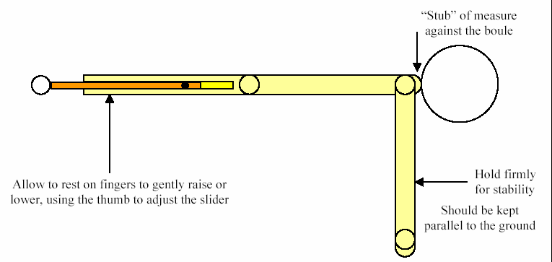

6. Measure each boule without touching the jack but as close as visually possible. Form a decision in your mind then return to the boule you consider is holding and remeasure but with touching the jack but not displacing it. Check the other boule and if the jack is not touched by the end of your measure your first decision can be confirmed.
7. Indicate the holding boule and verbally inform the players of your decision.
8. If a boule or jack is displaced by the Umpire it is returned to its original position by extending the right angle markings and remeasure or make an equitable decision if it is your second measure.
9. If a boule or jack is moved by a player while effecting a measure that team loses the point. The umpire should be called, and they will:
a) place the jack or boule to reflect the lost point if it has created an advantage to the team who moved the jack or boule.
b) If the movement has given the point to the opponents, it remains
c) The team losing the point must play the next boule.
This is an interpretation added to Article 28.of the rules.
10. In timed games haste is of the essence, be organised.

Note: You may if you wish, direct players to stand usually two metres away whilst you are measuring. Players should remain silent and abstain from commenting or moving about and casting shadows, which may distract you from your task. Any noncompliance with your directions and/or requests may be dealt with by any disciplinary action as deemed appropriate, according to the nature of the misdemeanour.

’Over-damaging’ of the terrain when marking the positions of the boules and/or Jack should be avoided where possible. On occasion, it may be necessary to use wedges to ‘chock’ a boule or the jack, protecting it against movement. Remember that the condition of the terrain must be restored on completion of measuring( usually by hand to allow the game to continue without advantage to any team or player.)

After Measuring:
Do not allow yourself to be drawn into a debate with any player or players with regards to your ruling. Be firm and decisive then walk away. If asked “how close was it” advise ‘close’ you have made a decision and you don’t have to justify it to the players.

It is acceptable (in fact advisable) to leave the marks that indicate the position of boule or jack, but these must not be so prominent as to constitute an obstruction should the boule or jack be moved validly by another boule.

Beware of the toes of your shoes making divots in the surface when you kneel to measure.

Marking the Boule or the Jack:

There are many reasons for marking the positions of boules and the jack. For instance, if a boule or the jack is dislodged for example by the wind, or a boule entering from another game, it may be replaced in its original position only if its position has previously been marked. Likewise, if a boule or the jack is moved whilst measuring, it may be replaced without penalty.

It is not, however, good enough to just scratch marks in the ground haphazardly. In order for the position to be accepted for the replacement of the boule or jack, it has to have been marked correctly.

Correct Marking of Jack and Boules

A minimum of two lines. Drawn at a right angle to the centre of the boule or jack
.

Lines drawn only at a depth, width and length to be able to be seen on the playing surface.
The lines must not affect the tracking of the boule or jack.
No line must be facing the circle or the jack.
The circle should be marked as shown in the event of it being accidently moved.

You need a right angle to find the centre point to replace a Boule or Jack more accurately

Right marking Imaginary squared lines

Lines extended to find centre

Incorrect markings

(No right angles)

Marking the position of a boule for removal by tapping it into the ground is not acceptable under any circumstances as it leaves an indentation in the surface which can hold the boule and any following boules played and should be penalised.

Using a tape measure for longer distances:
It is considered by many people, that an accurate measurement is not possible with the use of a tape measure. It is however possible to be reasonably accurate using a tape, but care must be taken to use the correct technique.

1. The tip of the tape should be placed lightly on the closest part of the boule.(Front edge)
2. Extend the tape past the jack and as close to the top of the jack as possible without touching it.
3. Read the measurement and repeat for the other boule. (make two measurements to be certain of a correct decision). If unable to make a decsion a team member should call the Umpire. Allowing the opposition to measure twice again can waste more time because of the closeness already known and having to call an Umpire anyway.

You should position yourself so that your line of sight is directly at 90º to the edge of the distance being measured. This will avoid inaccurate measurements due to error of parallax as illustrated below.
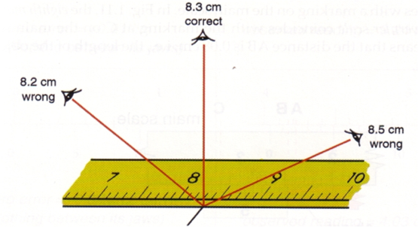

Callipers:
Using Callipers, the same care should be observed as for the previous examples, to ensure the correct positioning on the front of the boule and jack. One point of the callipers should rest lightly on the boule and be lifted away slightly whilst adjusting, to avoid the possibility of disturbing the jack in the instance of the callipers ‘springing’ open.
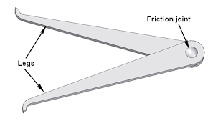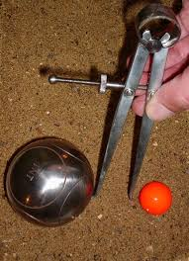

Using Feeler Strips:
There will be times where two or more boules are almost touching the jack, but with the slightest gap evident. On these occasions, it is necessary to use feeler strips (also known as feeler gauges) to measure the difference between. For this task, it is imperative that both the boules and the jack are marked. Then with steady hand, the strip is slipped alongside the boule and the jack before repeating for the other boule and comparing the difference between. If light is still visible between the strip and the boule, take the next thickness and remeasure until a decision can be ascertained.
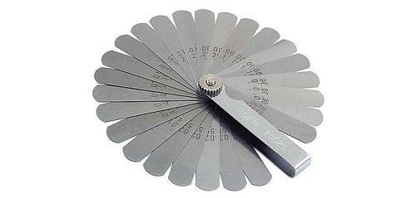

A torch shining from the back through the gap between the boule and jack and feeler strip may need to be used to help identify the size of the remaining gap sometimes.

Note: Great care must be taken when using this type of equipment. Whatever your choice of equipment, correct technique is of utmost importance.

Using Chocks

To avoid displacing boules or a jack especially when a boule needs to be lifted to achieve a measure between two boules and markings cannot be made accurately enough, chocks may need to be used.
Chocks can come in all different forms, larger for the boule, smaller for the jack, flatter to get under the boule, narrower to allow a folding measure to be used etc. Broken wooden pegs are one example.
Remember to place the boule you have removed in your bag or mark it with chalk so you know which boule you are going to put back and where. If more than one boule is to be liffed you can make a plan in your notebook. Use the boule serial numbers.

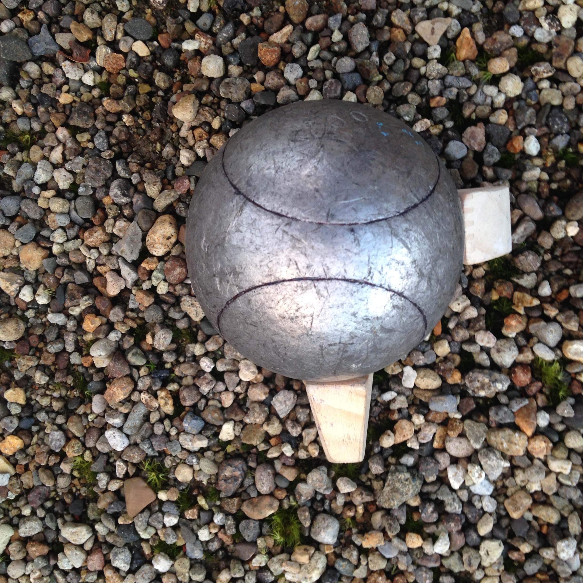
Chocks standing up. Below lying down.

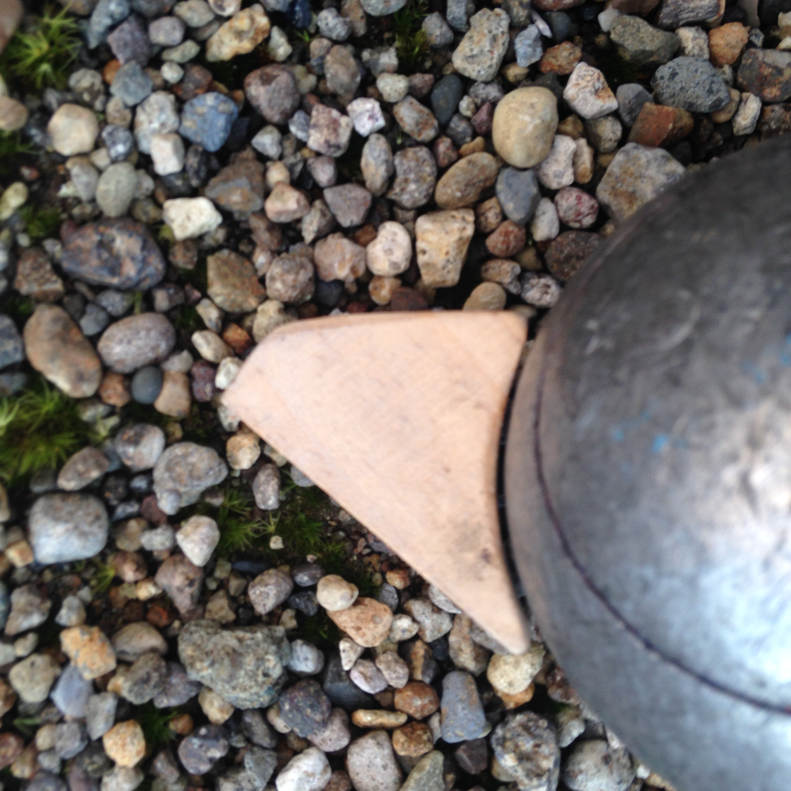

A flat shoe lace placed around the boule and pulled tight under the boule to be removed can also suffice.

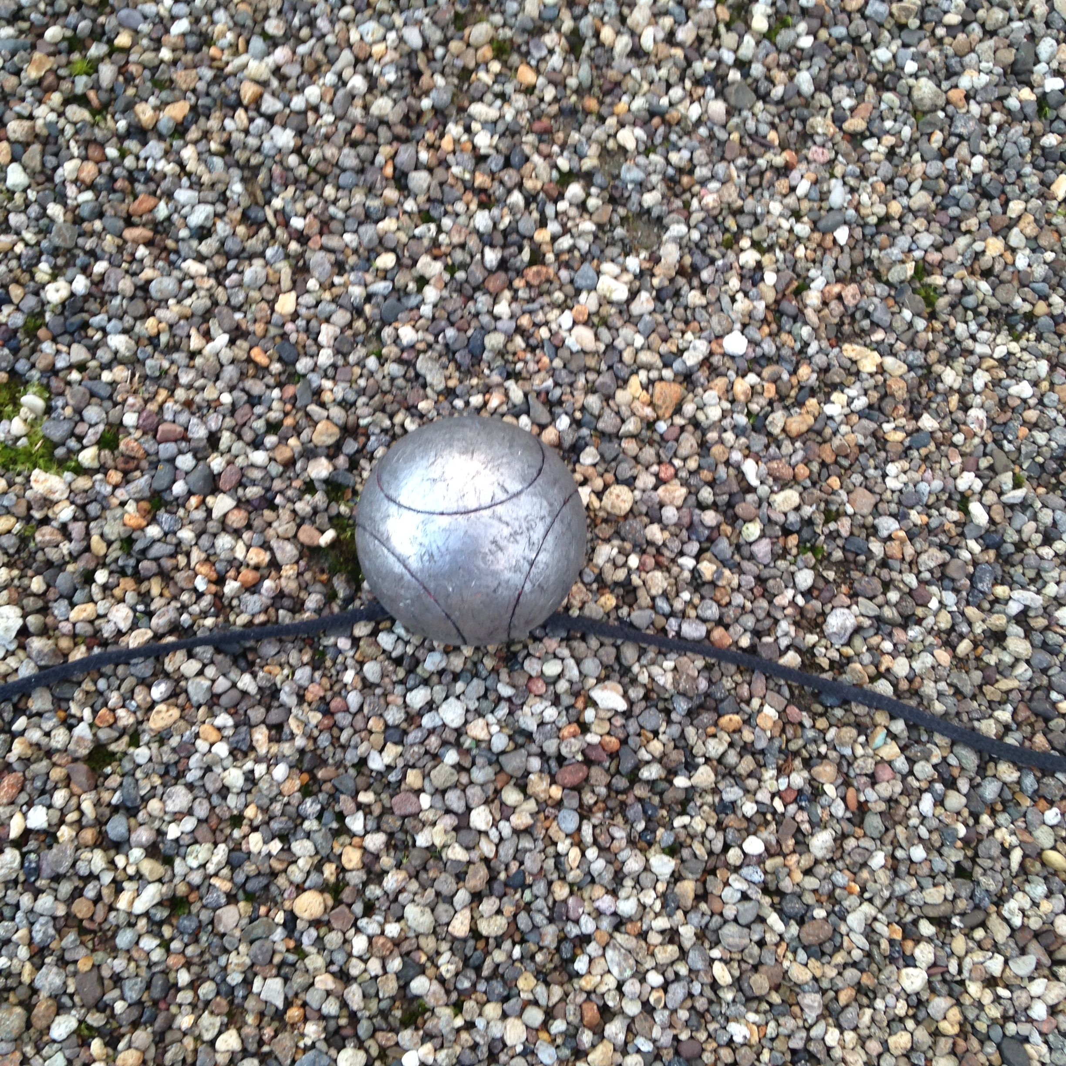

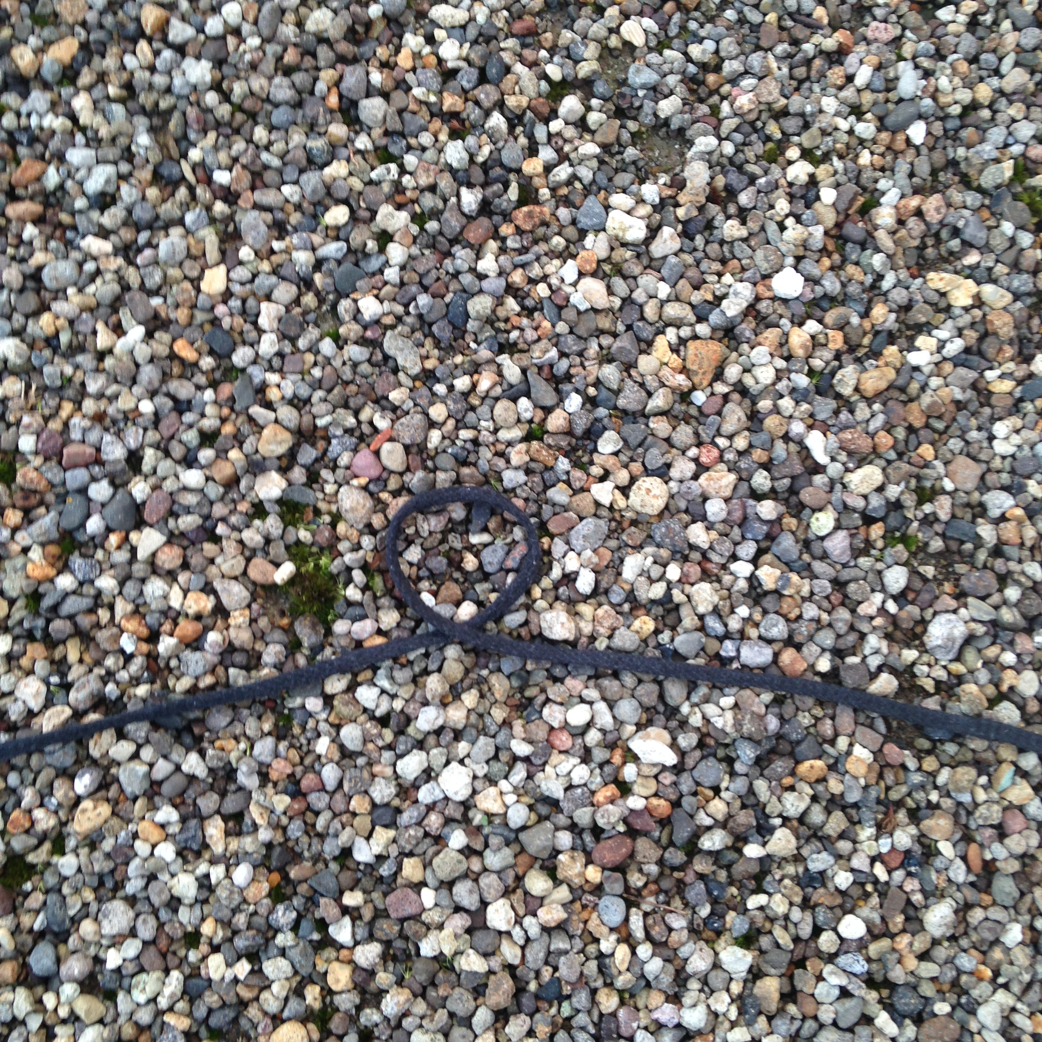

Vernier Callipers
Used for checking that boules and jacks conform to the diameters set out in the Rules
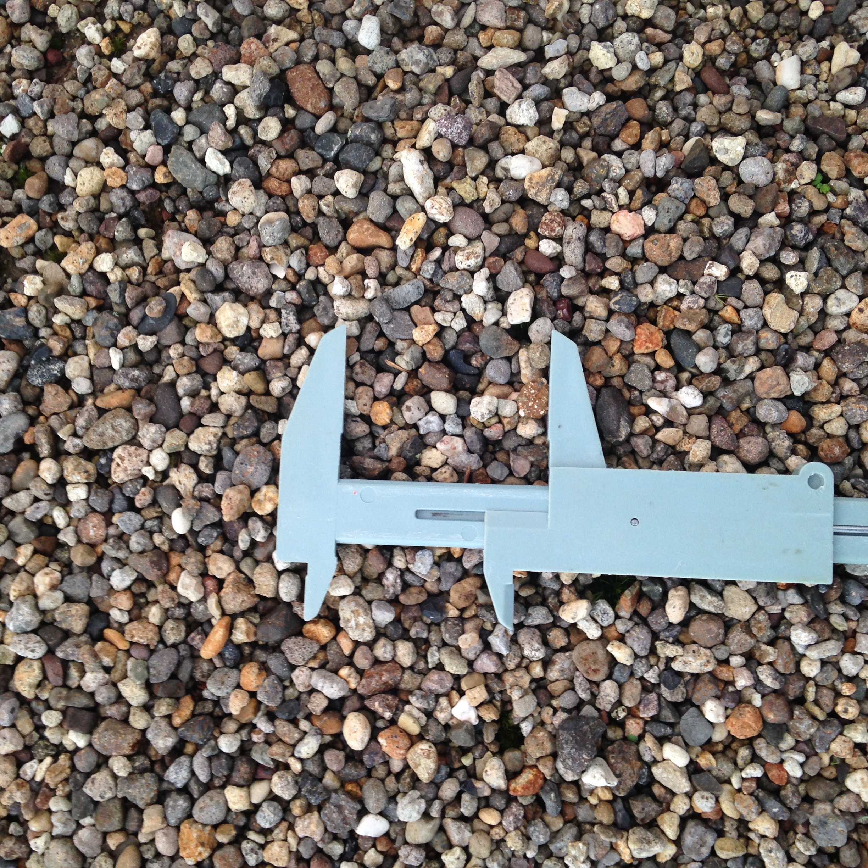

Scales
To weigh the boules and jack to ensure they conform to the Rules.

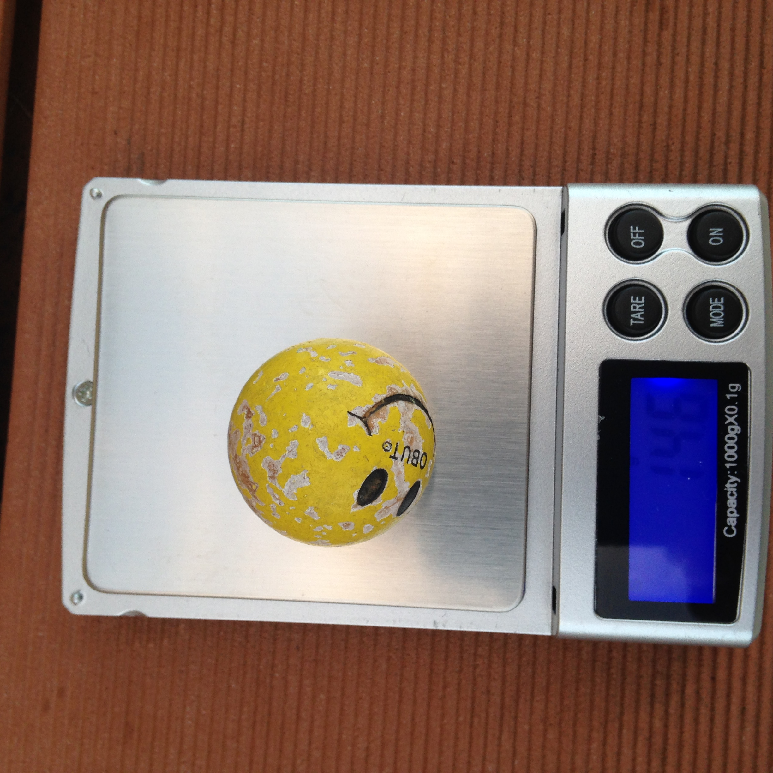

Stop Watch
Required for timing players who are to play their boule next or throw the jack.

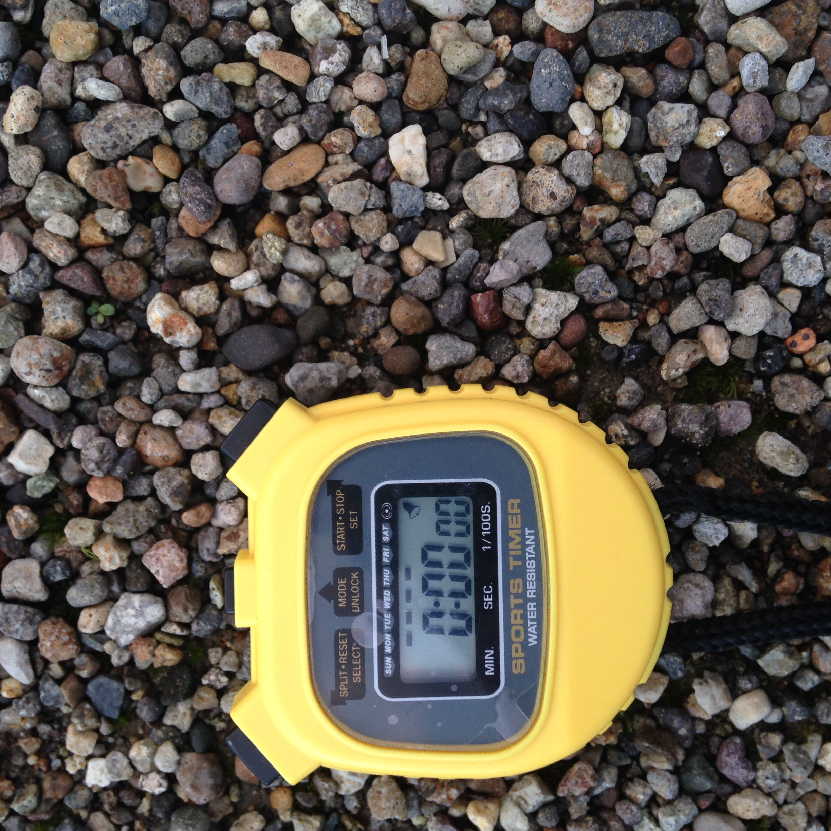

Interpretation

In a perfect world, all decisions and outcomes would be clear-cut. It is, however, a fact of life that this is not always the case when it comes to pétanque. Unfortunately, despite constant efforts and amendments by the International Congress each four years,the official F.I.P.J.P. rules still seem to be open to interpretation (or misinterpretation) by those not educated in the precise meanings of certain articles.

Interpretation of the rules and their application is one of the “greyer” areas (from the point of view of a player) with which the umpire must contend. The FIPJP Rules you will carry contains interpretations made by the Oceania and New Zealand Federations. Use them to educate players of the Rules after a game or as a moment allows.

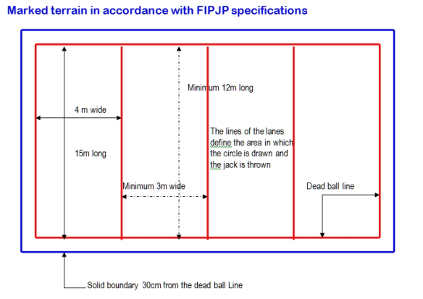
Note the red dead boule lines shown are for timed games. In untimed games the dead boule line is only the outer red terrain line as the internal red lines are only used when you throw the jack to 50cm’s from the lane line but if a boule or jack goes over the lane line it is still in. Not until the boule or jack has gone completely one lane each side of your lane is it out.

Terrains which are enclosed by walls/fences of a height which prevents a player standing or crouching and throwing a boule should have the dead boule line 1m in from the wall i.e. it is an obstacle. A side wall of the same or similar height only needs the side dead boule line 30cm from the wall as the boule can be visually seen moving over the line or rebounding of the wall. At the end of the piste where a wall/obstacle is in place the dead boule line should be 1m from the wall. If a lower board which is not an obstacle is placed between a front and back piste to stop the boule, the distance from the dead boule line and this board needs only to be 30cm but 50cm at both ends to make standing room is a good option.

NOTES

January 2019
UPNZ 3

